To MeBooks
Hao Jin
+60 16-224 2888

Design Recap
Thursday, 21 August 2025

No | Description | Qty
1 | Logo  - Logo  - Brand Guideline  - Logo Animation | 1
2 | Gift Card  - Art direction & text layouting  - ⁠Up to 2 sides  - ⁠Up to 3x minor revisions during design & creative process | 1

Project Timeline

August |  |  |  |  |  |  |  |  |  |  |  | September
20 | 21 | 22 | 23 | 24 | 25 | 26 | 27 | 28 | 29 | 30 | 31 | 1 | 2 | 3 | 4 | 5 | 6 | 7 | 8 | 9 | 10 | 11 | 12 | 13 | 14
Logo Proposal |  |  |  |  | Logo Propo- sal |  | Revision |  |  |  |  | Revision |  | Finalization |  |  |  |  | Finaliza-tion

September |  |  |  |  |  |  |  |  |  |  |  |  |  |  |  | October
15 | 16 | 17 | 18 | 19 | 20 | 21 | 22 | 23 | 24 | 25 | 26 | 27 | 28 | 29 | 30 | 1 | 2 | 3 | 4 | 5 | 6 | 7 | 8 | 9 | 10
Brand guideline draft |  |  |  |  |  |  | Brand guideline revision & finalization
Logo animation
 |  |  |  |  |  |  |  |  |  |  |  |  |  | Gift card draft |  |  |  |  |  |  | Gift card revision & finalization

Brand Brief:
- Brand Information:
  - An interactive children’s storytelling app designed to turn reading into an engaging, creative family experience.
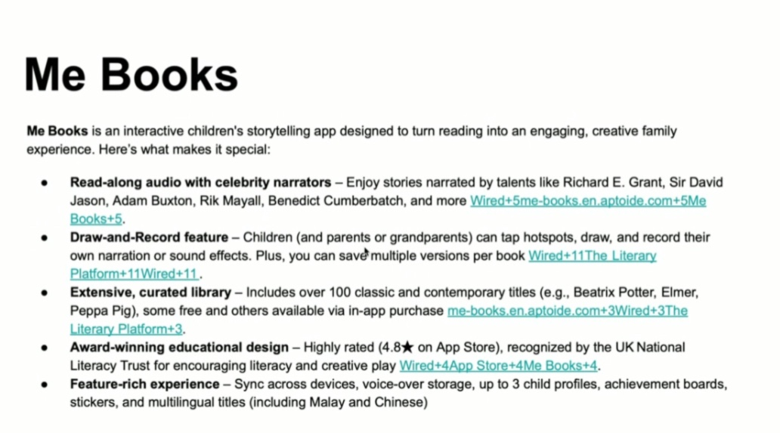
Logo Brief:
- Earlier version of the logo
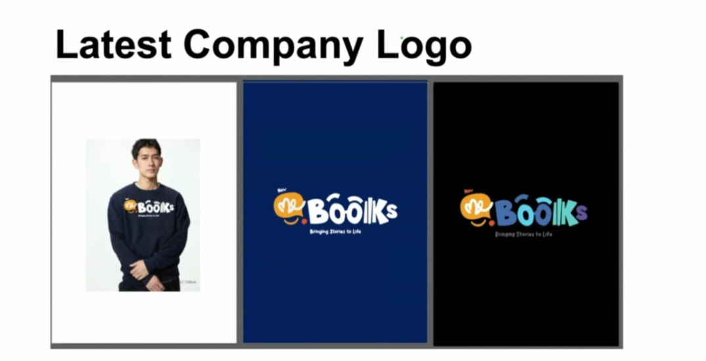
- Me Books will incorporate a mascot into its logo
  - Serve as a friendly “story guide” in the app and digital books.
  - Integrated into learning content, videos, and social media to explain educational topics in a fun way.
  - Extend to merchandise (plush toys, stickers, stationery) and event giveaways.
  - Strengthen brand recall among children, parents, and educators.

- Me Books Mascot:
  - SunBear
1sDz_r_xoHBq_bvb9Uzu5KLLM1M7EDRWr?usp=sharing

- Me Books would prefer:
  - A bright, bold, and creative color palette over softer “Zen” tones.
    - Typography: A modern sans serif base with soft, playful curves in selected letters.
    - Mascot: A friendly SunBear that can stand alone as an app icon or social media character.
    - Colors: High-energy combinations — e.g., vibrant teal, sunny yellow, coral red, and playful purple — ensuring strong contrast and maximum visibility across digital and print.
    - Mood: Playful, creative, and memorable while maintaining trust with parents, teachers, and institutional partners.

- Logotype references that are preferred:
  - Sora Kid:
    - Clean
    - Professional base font that pairs well with a mascot for flexibility in different uses.
    - Incorporating the mascot will be essential to keeping the brand playful
    - Fonts that incorporate shapes or meaningful elements into the letters themselves, so there's no need for a separate icon.
      - Similar to the current Mebooks logo style, but designed to look more modern and minimal.
  - Pega-Pega:
    - Vibrant
    - Dynamic
    - Fun — eye-catching for kids.
    - Playful fonts - can experiment with their orientation and tilt/angle.
Picture references
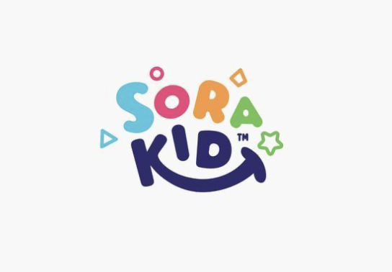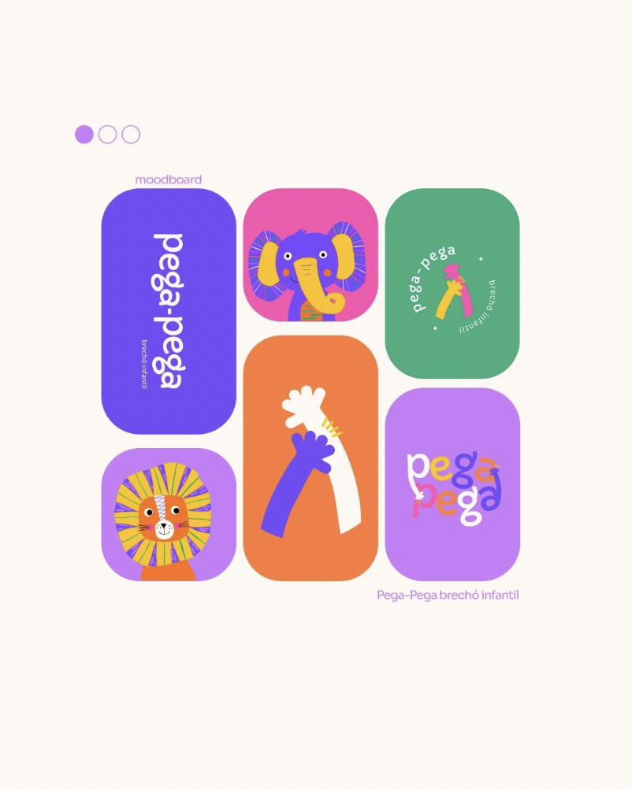

- Logotype references that are less preferred:
  - Kid:
    - Too generic
  - Little Happy Learner:
    - More like a fashion brand for kids
  - Kid Garden:
    - Not the best option
Picture References

