KOL Talking Points

Hello everyone! Today, I want to introduce what I believe is currently the most promising Web3 product—MTT Sports. In terms of both gaming experience and earning potential, I think it stands head and shoulders above other Web3 games.
The gameplay is based on the familiar Texas Hold'em style, with multi-table tournaments in the MTT format. Players can join the game for free.
Its development team is exceptionally strong, and they even built a blockchain in the Cosmos ecosystem specifically for this product, which is also compatible with EVM. It seems there will be a lot of ecosystem development in the future. Now, let me walk you through the details of this product.

Part 1. Advantages
- Experience
First of all, the user experience is incredibly smooth. It's a top-tier poker tournament product on the market. You can easily log in via web browsers on both PC and mobile devices. The gameplay is also very well-rounded, allowing players to use emojis and send gifts during hands. The overall polish and completion of this product are truly impressive!

Guided Steps:
- Start by entering the website, logging in, and registering for the game. Once you're in the game interface, talk about the smooth user experience and how seamless the operations feel. Compare it to similar products on the market like GG Poker or PokerStars, highlighting that MTT Sports is at least on the same level, if not surpassing them, as a top-tier product.
- Switch to the gameplay screen. While playing, use emojis, send voice messages, and type in the chat. Open the in-game shop, take a look around, and explore the gifts and other items available.

- Free
Additionally, this is a truly free-to-play, earn-to-win Web3 game. The rules of Texas Hold'em are very simple—just play, and you can earn tokens without the need to buy any NFTs in advance.
Also, here’s a sharing link: when the friends you invite win rewards in tournaments, the platform will reward you with an additional percentage. This is another great way to earn tokens!

Guided Steps:
- Explain to the players that even if they don't know how to play poker, they can learn the game rules, and with just a few good hands, they can easily make it into the money circle and earn MTT tokens. For example, you can go all-in a few times and sneak into the money circle, and tokens will be in your wallet. Show your wallet to demonstrate this, or you can display the game history of the hands you just played, emphasizing that MTT tokens have been credited to your wallet.
- Most importantly, you can join games without any upfront costs, especially in beginner tournaments. Unlike other blockchain games like StepN or Axie, where you need to purchase NFTs in advance.
- Open the "Invite Friends" button and link, and explain the benefits of sharing with others.

- BTC：
Another standout feature of this game is that, aside from MTT tokens, real Bitcoin (BTC) rewards are also up for grabs to attract a large number of users. Every week, players can either qualify through daily tournaments or directly purchase tickets to enter the weekly tournaments. The weekly tournaments offer huge BTC prizes, and starting in October, 1 BTC grand prize every week! Just take a look at the leaderboard—these top players are raking in the rewards! Some have even won multiple times.
Guided Steps:
- (Insert a note about the value of BTC here: "Not many people know about this product yet; I checked their Twitter, and they only have just over 100 followers. Let’s go take advantage of this early opportunity!")
- Switch to the tournaments page. Introduce the location of the daily tournaments, explain the rewards for the daily tournaments, which include MTT tokens and entry tickets. Then introduce the weekly tournaments, where the grand prize is BTC.
- Switch to the leaderboard page and showcase the players currently on the leaderboard.

- Future multi-event model
"Wait, does this game also have a CLUB mode? That means we can organize our own tournaments, right??? If I understand correctly, our community can set up our own matches in the future, freely customizing the tournaments. Later on, you all can join the tournaments I organize—I’ll arrange a big prize pool for everyone!

Guided Steps:
(1) Mention this while playing or weave it into any part of your session."

- Presumed Project Background
The team and investors behind this project must be incredibly strong. Although the team is currently anonymous, the smoothness of the product and the development of the blockchain clearly show that this isn’t something a small team could accomplish. The research into poker algorithms, the fair dealing mechanism, and the on-chain verification are not things an ordinary team could handle. For instance, the ability to verify all hands online requires a strong technical foundation. There are many details involved here, but we won’t dive into the technical aspects for now.
Guided Steps:
Take a moment to check out the RNG (Random Number Generator) dealing mechanism. If possible, expand on this mechanism to provide more context.

- Project logic: Starting from the market business model of project web2
As far as I know, Web2 poker projects are very profitable. Transitioning to Web3 is like a fish finding water. If they were making money in Web2, leveraging the high efficiency and liquidity of Web3 should also be profitable. As long as the project is profitable and people are playing, the economic model will be healthy and sound. For those of us who are early participants, the tokens we acquire easily now will become valuable. Based on past experience with Web3 projects, getting in now is definitely not a loss, especially given their current low follower count on Twitter—this seems to be a cold start phase. Let’s wait and see; once the whitepaper is out, we can dive deeper into the details!

Part 2. Disadvantages/Expectations:

The only downside I’ve found with this project is the facial recognition requirement. To participate and earn rewards, you must verify that you’re a real person through facial recognition, which can be a bit cumbersome. However, this is understandable given the real money rewards involved—without this verification, ordinary players might be at a disadvantage compared to more sophisticated players. This measure ensures fairness for all players. Additionally, it seems that logging in becomes more convenient after your facial data is recorded. So, this slightly cumbersome process is something to consider, but everyone can form their own opinion on it.
Guided Steps:
Record the facial recognition process.

Additionally, are there any other financial Web3 features for the token that can generate more income? Currently, you can stake 1,000, 10,000, or 100,000 tokens to become a VIP member. Let’s see if there will be other token utilities in the future.
Guided Steps:
Check out the VIP interface. Build anticipation by highlighting that there will definitely be more token utilities and ways to earn in the future. Emphasize that the token will have additional features and benefits.

Part 3. Roadmap：
1、In September, this project also participated in the Token2049 event in Singapore as a platinum sponsor, which is a significant achievement. They are likely to announce some new developments, so keep an eye on it and see what their token plans are. As long as the project operates smoothly and users can continue to engage with the platform long-term, the economic model will be solid. The tokens we earn now will become valuable!
Guided Steps:
- Open the Token2049 official website and take a screenshot of MTT's sponsorship position.
- You can highlight and exaggerate the potential of the MTT token. For example, compare its future value and benefits to other types of tokens, emphasizing that MTT could surpass them due to its strong backing and promising economic model.

Weekly Tournament From 10.1 on
Starting October 1, we will upgrade the Weekly Tournament. After the upgrade, the weekly tournament rewards will be 1 Bitcoin plus at least 100,000 MTT tokens. Everyone can join this event for free.
Phase 1: From October 1 to October 4, participate in our Seat Tournaments to secure a seat.
Phase 2: Starting October 5, there will be a three-day elimination tournament, from DAY 1 to DAY 3, with the final day featuring the Final Table competition.
The final table will share the prize pool, with the champion receiving 0.5 BTC and 5,000 MTT tokens. This Weekly Tournament will continue indefinitely, with 100 Bitcoins prepared as rewards.

Attract attention:
You should definitely check out their official website and Twitter, and join their Discord. They are currently in the cold start phase, so even though there aren’t many people yet, I like new projects like this—it means we’re among the very first! The tournaments are already up and running, and tokens are directly credited to your official wallet address. Get in early, as these are free tokens, and who knows, you might just win 1 BTC!
Guided Steps:
- Open Twitter and Discord to check their latest content and updates.
- Showcase the content to demonstrate the current status and opportunities.

Other points：
Comparing with Global Poker Tournaments:
When we look at global poker tournaments like the World Series of Poker (WSOP), we see the immense scale and prestige they have in the Web2 world. The question now is whether MTT Sports can surpass this scale in the Web3 environment. With its innovative features, such as seamless integration of blockchain technology and real-time token rewards, MTT Sports has the potential to revolutionize the industry. By leveraging Web3's efficiency and liquidity, MTT Sports could break the traditional boundaries of Web2 tournaments and set new standards for global poker events. This is an exciting possibility, and it will be interesting to see how MTT Sports evolves to compete on this level.
Future Potential with Community Tokens and Rewards:
Looking ahead, using this platform to host tournaments with other community tokens and rewards could be incredibly exciting. Imagine participating in tournaments that feature various community tokens as prizes or where different reward structures are implemented. This flexibility could attract diverse communities and create unique gaming experiences. It opens up possibilities for collaborations and integrations with other projects, adding more value and variety to the platform. Engaging with different tokens and rewards could enhance the platform’s appeal and foster a dynamic ecosystem.

Part 4. First Week BTC Events
The first week of the Bitcoin Upgrade Tournament, which started on October 1st on MTT Sports, has ended! They really gave away 1 Bitcoin, and the lucky winners who received it have already shared their excitement on Twitter. The official site has also posted their tweets on the homepage: https://sports.mtt.xyz/
（Slide and Click）
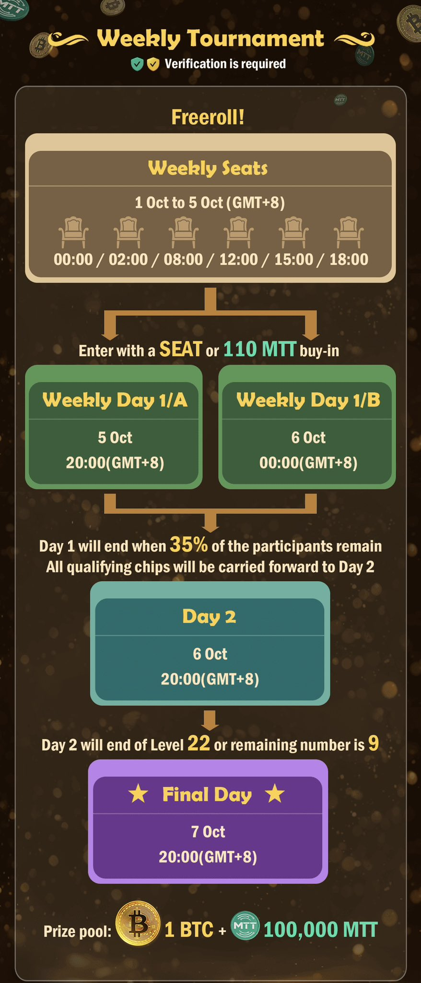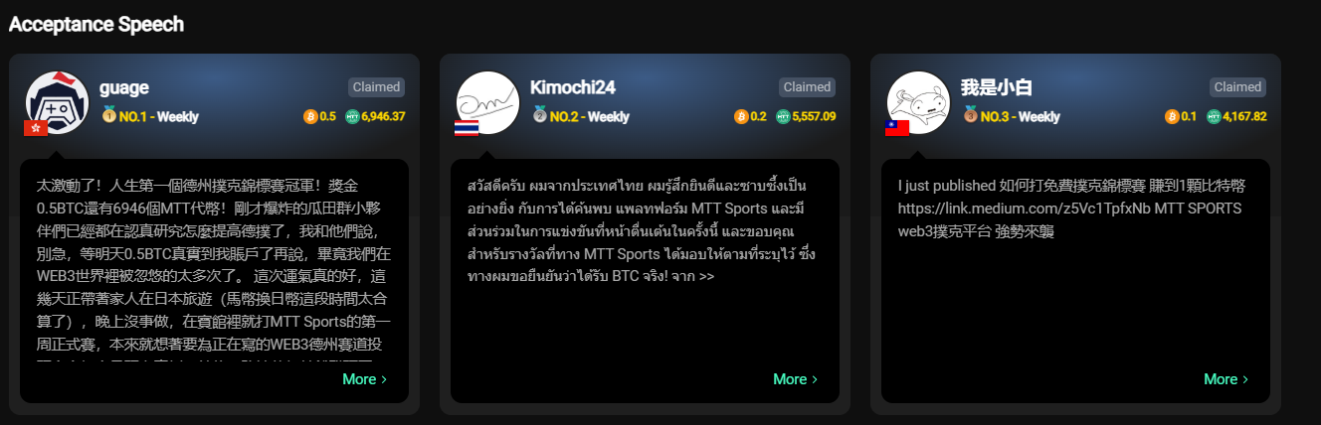

Is this tournament really going to last for 100 weeks? I feel like I need to seriously learn how to play Texas Hold'em. This week's tournament has already started, and since it's just the beginning, I believe there won't be too many participants yet, so everyone still has a good chance to rank high. Additionally, the MTT tokens they've distributed have already started being traded outside of the group, and it's rumored that they've risen to 0.1u each. The prize pool for MTT is around 30%, so the probability of winning MTT is still quite high. Besides Bitcoin, there are also 100,000 MTT tokens up for grabs in the weekly tournament.
This platform also offers mining tournaments, daily tournaments, and Hawk tournaments, giving everyone plenty of opportunities to earn MTT rewards for free. Don't hesitate—practice your Texas Hold'em skills and go grab some BTC.
I'll go over the Bitcoin tournament format again: The first few days of each week feature seat qualifiers, which are free to enter and very easy to earn a spot. If you don't have a seat, entering the Bitcoin main event will cost 110 MTT. The main event lasts three days, with eliminations continuing until the Final Table. For detailed information, refer to the long image below.

Part 5. High Roller
Recently, we were pleasantly surprised to discover that MTT Sports updated the gameplay of the High Roller Tournament, with a guaranteed prize pool of 10,000 MTT. The dynamic prize pool is determined based on the number of registrations and rebuys. This time, the dynamic prize pool reached over 20,000, and the total prize pool was 30,000 MTT. We saw that the first-place winner ended up taking home more than 6,000 MTT, while the entry fee was only 220 MTT, giving nearly a 30x return, truly a small investment for a big win.
We calculated that the first High Roller Tournament had only 115 participants, with 37 re-entries. This means the platform received a total of 32,626 MTT, and after subtracting the 30,096 MTT prize pool, there were 2,530 MTT remaining, which represents the platform’s revenue. According to the whitepaper, these tokens will go into the treasury, so concerns from many friends about platform profitability and the circulation of MTT have been addressed to some extent. After all, this business model has been proven in Web2. From this detailed gameplay, we have reason to believe that the entire project can achieve a very stable cycle in the future, and the value of MTT will ultimately be secured!"
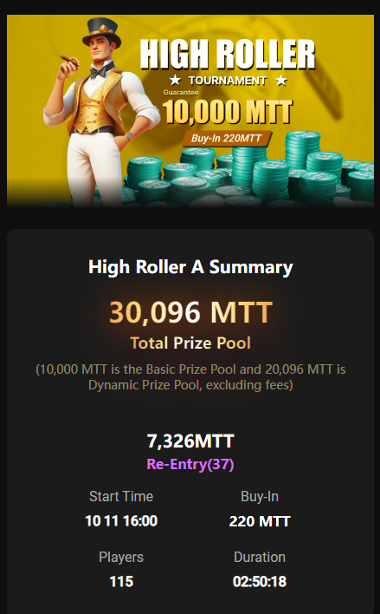 | 